**Name: Samarth Jain**

**USN: 4SU20CS081**

**Course: Cybersecurity**

**Trainer: Bharath Kumar**

**Date: 22/08/2023**

**Assignment Details**

Assigned Date: 21-08-2023

Due Date: 22-08-2023

Topic: Port Scanning

**Introduction**

For this assignment, I conducted a port scanning exercise using the nmap command within Kali Linux. I targeted three distinct machines on the network to identify open ports and services. By executing the nmap command with appropriate flags and specifying the IP addresses of the target machines.

**Content**

**METASPLOITABLE2**

Metasploitable is a purposely vulnerable virtual machine (VM) that's used for training, practicing, and demonstrating various cybersecurity techniques and tools, particularly penetration testing and ethical hacking. It's designed to simulate a range of security vulnerabilities and weaknesses commonly found in real-world systems, making it an ideal environment for security professionals, students, and researchers to learn about and practice exploiting vulnerabilities in a controlled and safe setting.

Port scanning is a technique used to discover open ports on a target system. It involves sending network requests to a range of ports on a target system and analyzing the responses to determine which ports are open, closed, or filtered. Nmap (Network Mapper) is a popular open-source tool used for port scanning and network discovery.

**IPv4 address: 10.0.2.5**

**Commands:**

*nmap 10.0.2.5*  //Basic Scan

*nmap -sV 10.0.2.5* //Version Detection

*nmap -T4 -A 10.0.2.5*  //will get version, OS, certificates and keys

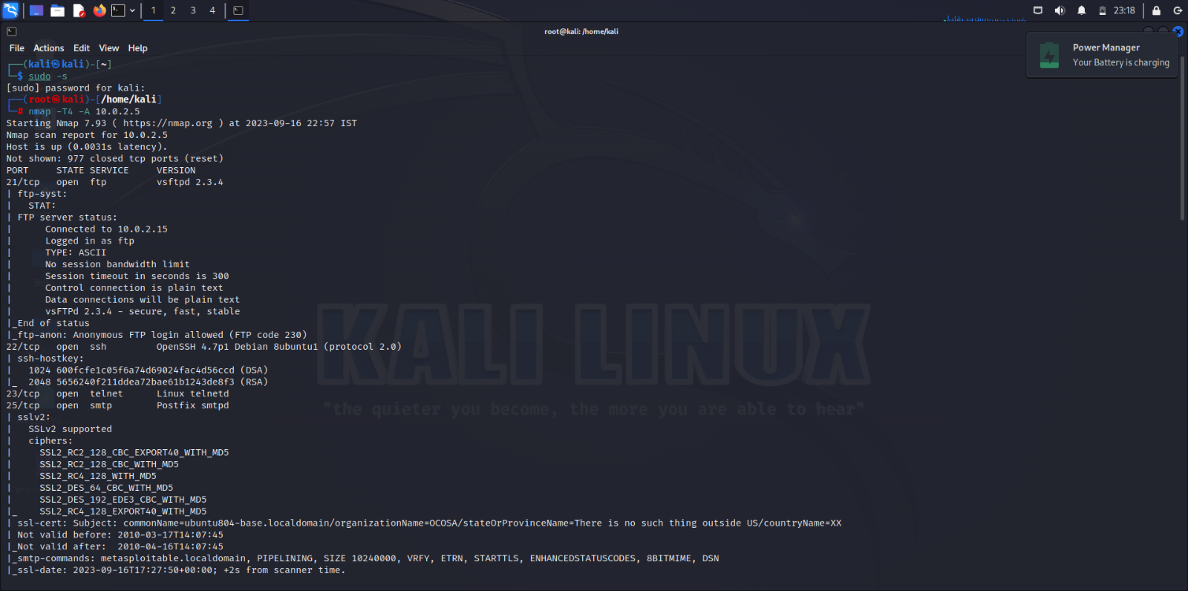

|  |  |  |
| --- | --- | --- |
| **Open Ports**  21/tcp ftp  22/tcp ssh  23/tcp telnet  25/tcp smtp  53/tcp domain  80/tcp http  111/tcp rpcbind  139/tcp netbios-ssn  445/tcp microsoft-ds  512/tcp exec  513/tcp login  514/tcp shell  1099/tcp rmiregistry  1524/tcp ingreslock  2049/tcp nfs  2121/tcp ccproxy-ftp  3306/tcp mysql  5432/tcp postgresql  5900/tcp vnc  6000/tcp X11  6667/tcp irc  8009/tcp ajp13  8180/tcp unknown | **Service Version**  vsftpd 2.3.4  OpenSSH 4.7p1 Debian 8ubuntu1 (protocol 2.0)  Linux telnetd  Postfix smtpd  ISC BIND 9.4.2  Apache httpd 2.2.8 ((Ubuntu) DAV/2)  2 (RPC #100000)  netbios-ssn Samba smbd 3.X - 4.X (workgroup: WORKGROUP)  netbios-ssn Samba smbd 3.X - 4.X (workgroup: WORKGROUP)  netkit-rsh rexecd  GNU Classpath grmiregistry  Metasploitable root shell  2-4 (RPC #100003)  ProFTPD 1.3.1  MySQL 5.0.51a-3ubuntu5  PostgreSQL DB 8.3.0 - 8.3.7  VNC (protocol 3.3)  (access denied)  UnrealIRCd  Apache Jserv (Protocol v1.3)  Apache Tomcat/Coyote JSP engine 1.1 | **Operating System**  Metasploitable2 (Linux) |

**WINDOWS7**

**IPv4 address: 10.0.2.4**

**Commands:**

*nmap 10.0.2.4*  //Basic Scan

*nmap -sV 10.0.2.4* //Version Detection

*nmap -T4 -A 10.0.2.4*  //will get version, OS, certificates and keys

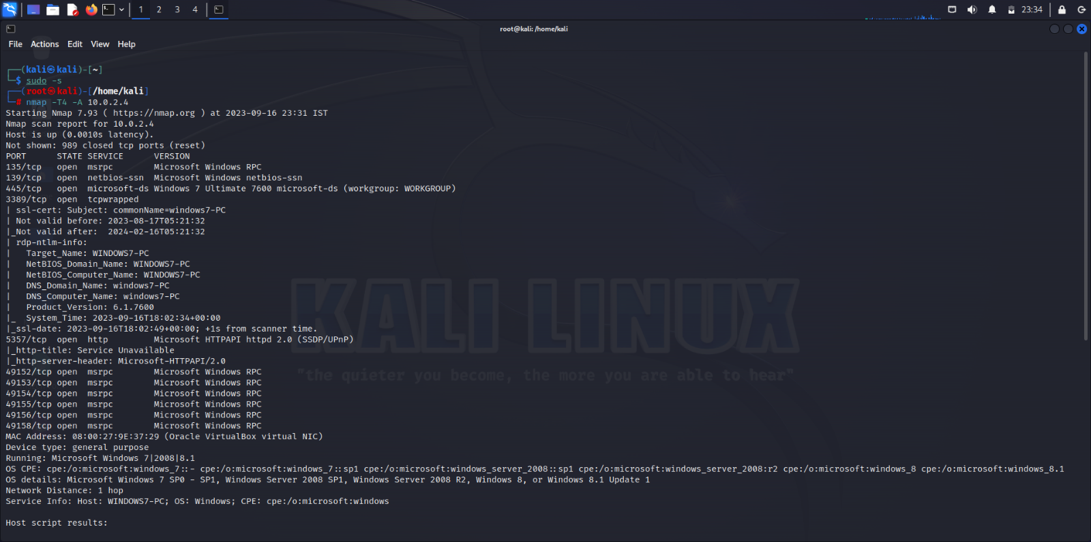

|  |  |  |
| --- | --- | --- |
| **Open Ports**  135/tcp msrpc  139/tcp netbios-ssn  445/tcp microsoft-ds  554/tcp rtsp  2869/tcp icslap  3389/tcp ms-wbt-server  5357/tcp wsdapi  10243/tcp unknown  49152/tcp unknown  49153/tcp unknown  49154/tcp unknown  49155/tcp unknown  49156/tcp unknown  49158/tcp unknown | **Service Version**  Microsoft Windows RPC  Microsoft Windows netbios-ssn  Microsoft Windows 7-10 microsoft-ds(WORKGROUP)  Microsoft HTTPAPI httpd 2.0 (SSDP/UPnP)  Microsoft HTTPAPI httpd 2.0 (SSDP/UPnP)  Microsoft HTTPAPI httpd 2.0 (SSDP/UPnP)  Microsoft Windows RPC  Microsoft Windows RPC  Microsoft Windows RPC  Microsoft Windows RPC  Microsoft Windows RPC  Microsoft Windows RPC | **Operating System**  Windows7 |

**scanme.nmap.org (Website)**

**IPv4 address: 45.33.32.156**

**Commands:**

*nmap 10.0.2.4*  //Basic Scan

*nmap -sV 10.0.2.4* //Version Detection

*nmap -T4 -A 10.0.2.4*  //will get version, OS, certificates and keys

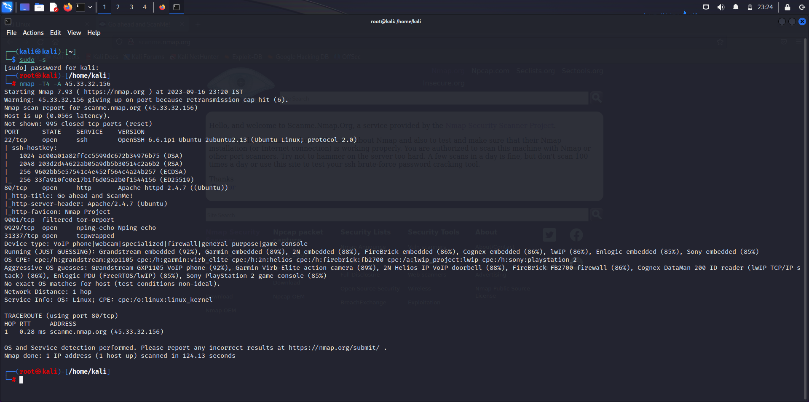

|  |  |  |
| --- | --- | --- |
| **Open Ports**  22/tcp ssh  80/tcp http  9001/tcp  9929/tcp  31337/tcp Elite tcpwrapped | **Service Versions**  OpenSSH 6.6.1p1 Ubuntu 2ubuntu2.13 (Ubuntu Linux; protocol 2.0)  Apache httpd 2.4.7 | **Operating System**  Ubuntu (Linux) |

**Analysis**

The Nmap scan of the target website revealed a range of open ports and associated services. The scan indicated a diverse set of services including FTP, SSH, HTTP, SMTP, and more. Additionally, the presence of outdated or potentially misconfigured services like Telnet and anonymous FTP access raised concerns about potential security vulnerabilities. The scan underscores the importance of maintaining updated and secure service configurations to mitigate possible exploitation risks.

**Conclusion**

In conclusion, the Nmap port scan of the target website provided valuable insights into the network's exposed services and potential security vulnerabilities. The wide range of open ports revealed a diverse set of services, highlighting the need for robust security measures to protect against potential attacks. The presence of outdated or insecure services, such as Telnet and anonymous FTP access, underscores the importance of regular security assessments and updates. However, it is crucial to stress that ethical considerations and proper authorization are paramount when conducting any form of scanning. By adhering to ethical guidelines and maintaining vigilant security practices, organizations can better safeguard their digital assets and maintain a strong security posture.

**References**

[An InfoSec Blog for anyone interested to learn security and Hacking (wordpress.com)](https://hackwithbkob.wordpress.com/)

[Nmap: the Network Mapper - Free Security Scanner](https://nmap.org/)